L47 – SohCahToa Review
Part 1 – Labelling Sides
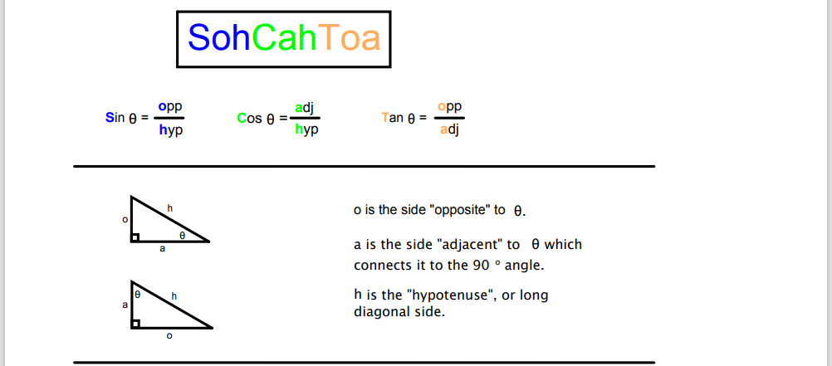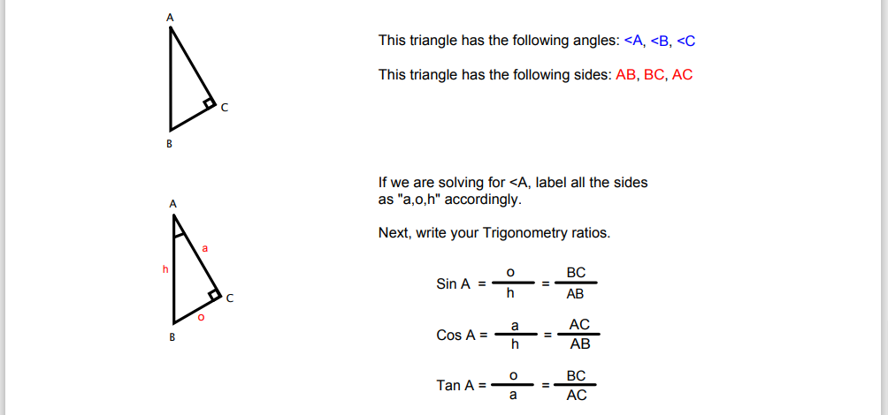

Use the following information to answer Q1:
Labelling the Sides of a Triangle
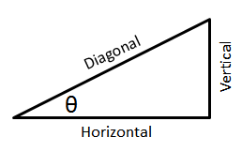
Side Orientation
1 – Diagonal
2 – Horizontal
3 – Vertical

Q1: Use the numbers above to identify each side of the triangle.

Orientation: __________ __________ __________
Description: Adjacent Hypotenuse Opposite

(Record your three-digit answer in the Numerical Response boxes below)

Use the following information to answer Q2-Q4:
Trig Ratios for a 7-24-25 Triangle
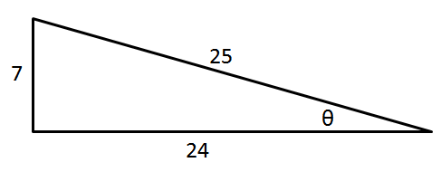

Q2: $Sin θ=\frac{a}{bc}$ where the integers a, b, and c are ___, ___, and ___.
(Record your three digit answer in the Numerical Response boxes below)

Q3: What is the value of $Cos θ$, to the nearest hundredth?
(Record your answer in the Numerical Response boxes below)

Q4: $Tan θ$ is a.bc x 10^{-d}, where a, b, c, and d are ___, ___, ___, and ___.
(Record your four-digit answer in the Numerical Response boxes below)

Part 2 – Solving for Angles
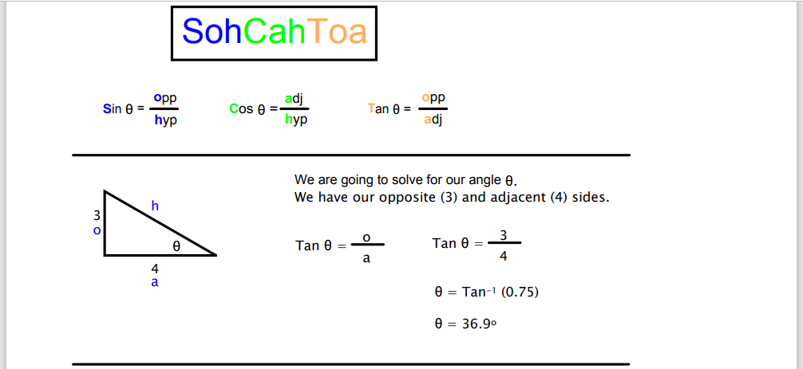

Use the following information to answer Q5-Q7:
Trig Ratios for a 3-4-5 Triangle
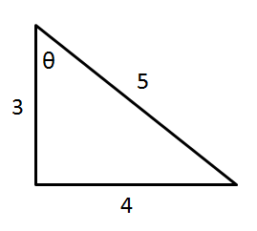

Q5: For the triangle above, the ratio $Tan θ=\frac{d}{e}$ where the integers d and e are ___ and ___.
(Record your two digit answer in the Numerical Response boxes below)

Q6: What is the value of $Tan θ$, to the nearest hundredth?
(Record your answer in the Numerical Response boxes below)

Q7: What is the value $θ$?
(Record your two digit answer in the Numerical Response boxes below)

Q8: Solve for the angle β. (2 marks)
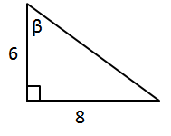

Q9: Solve for the angle ∠C. (2 marks)
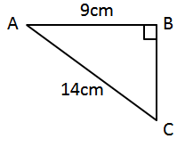

Part 3 – Solving for Sides
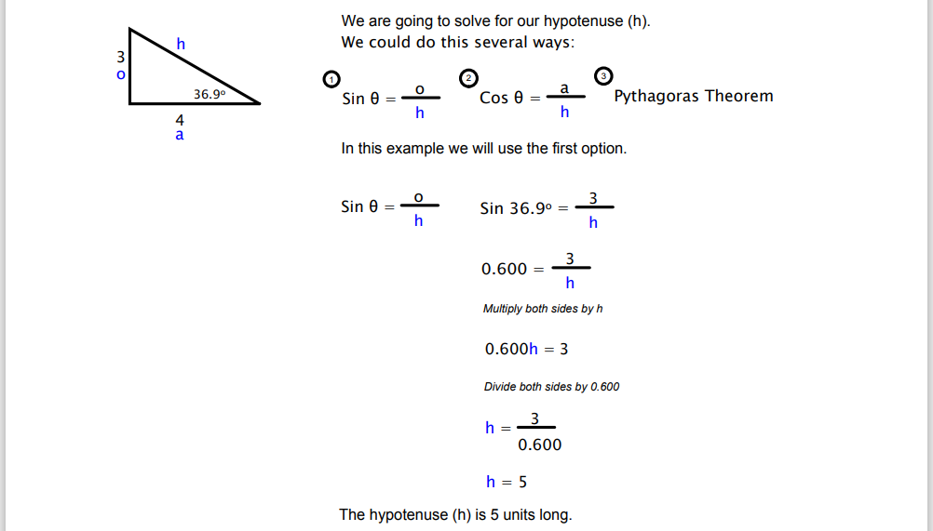

Use the following information to answer Q10-Q11:
Solving for ∠A
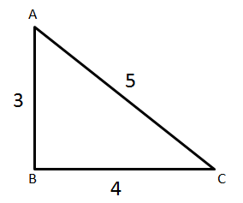
Trigonometric Ratio
1 – Sin
2 – Cos
3 – Tan

Q10: To solve the triangle above for ∠A, we will use a trigonometric ratio d from the text box above. The value of this ratio is $\frac{e}{f}$ , where d, e, and f are ___, ___, and ___.
(Record your three digit answer in the Numerical Response boxes below)

(Multiple correct answers will be accepted)

Q11: What is the value of ∠A?
(Record your three digit answer in the Numerical Response boxes below)

Use the following information to answer Q12-Q13:
Solving for Side “b”
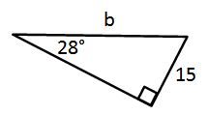

Q12: To solve the triangle above for side b, we will use which trigonometric ratio?
- Sin
- Cos
- Tan
- All of the above

Q13: What is the value of b, to the nearest tenth?
(Record your answer in the Numerical Response boxes below)

