L48 –Sine Law
Key Ideas
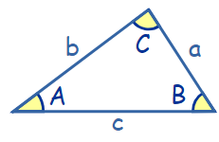
Sine Law:
$\frac{SinA}{a}=\frac{Sin B}{b}=\frac{Sin C}{c}$ or $\frac{a}{Sin A}=\frac{b}{Sin B}=\frac{c}{Sin C}$

Part 1 – Solving for a Side
Q1: Find the length of x. Q2: Find the length of a. Q3: Find the length of AC
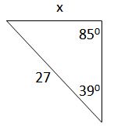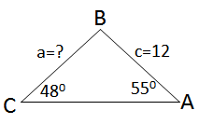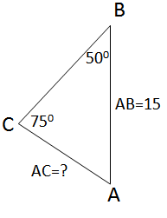

Part 2 – Solving for an Angle
Q4: Solve for θ. Q5: Solve for ∠B. Q6: Solve for ∠ABC.
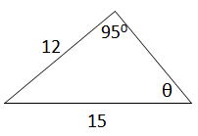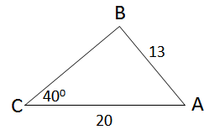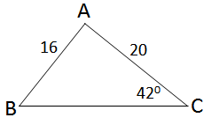

Q7: Solve for x.
.
