L48 – Worksheet –The Sine Law
Quick Note
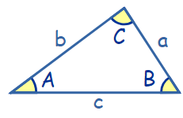
Sine Law:
$\frac{SinA}{a}=\frac{Sin B}{b}=\frac{Sin C}{c}$ or $\frac{a}{Sin A}=\frac{b}{Sin B}=\frac{c}{Sin C}$

Note: Questions have been taken from the Math 20-1 textbook, but are appropriate for Ma20-2.
Part 2 – Textbook Questions
Pg 108 #2: Determine the length of AB in each.
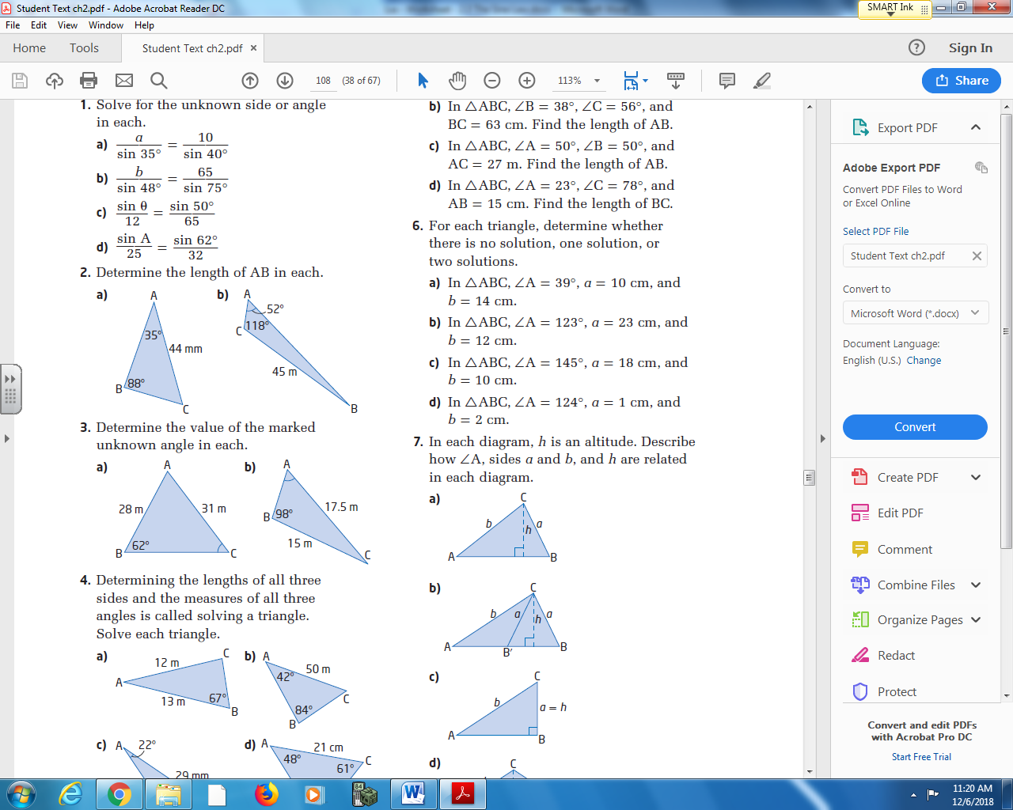

Pg 108 #4cd: Determining the lengths of all three sides and the measure of all three angles is called solving a triangle. Solve each triangle.
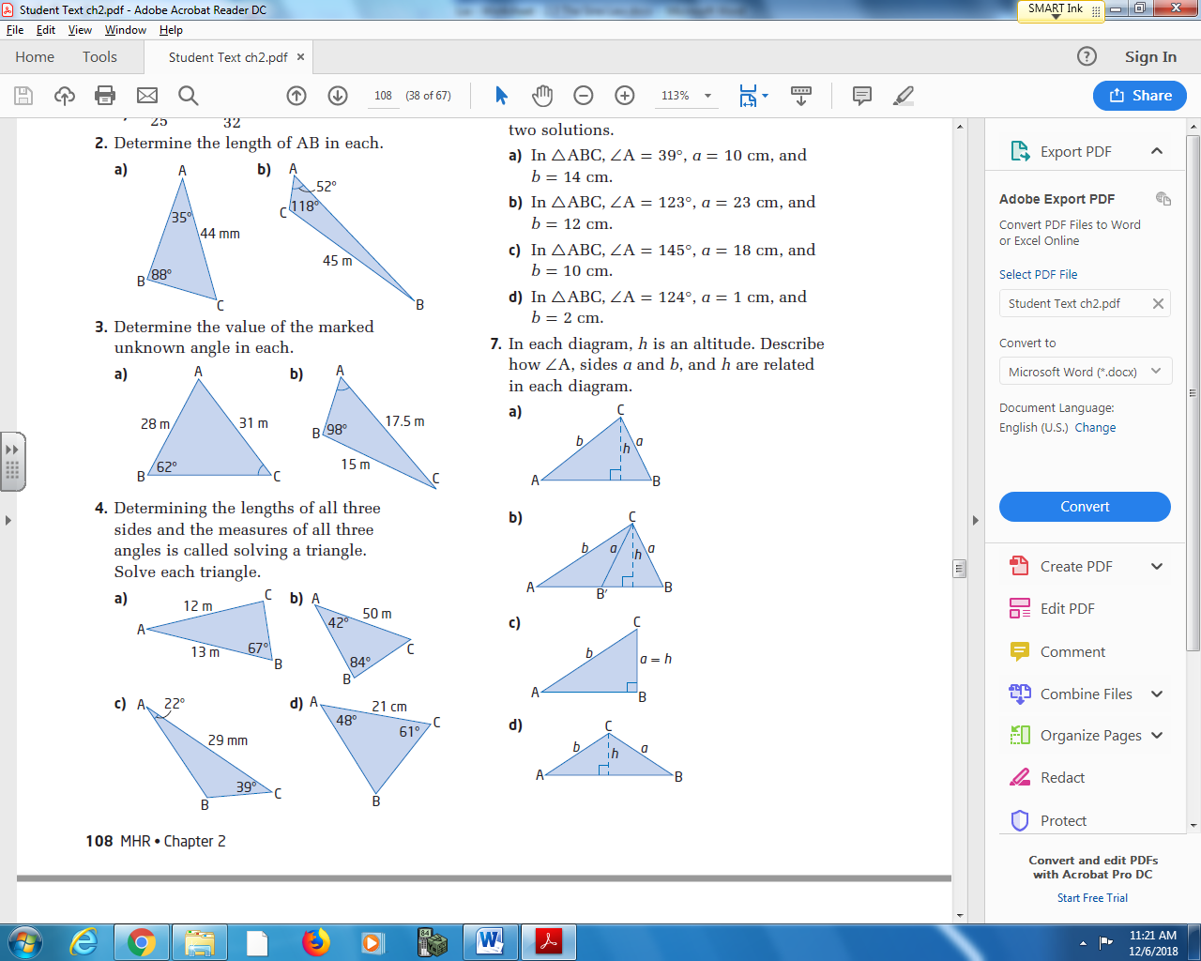

Pg 108 #5ab: Sketch each triangle. Determine the measure of the indicated side.
In ΔABC, ∠A = 57⁰, ∠B = 73⁰, and AB = 24cm. In ΔABC, ∠B = 38⁰, ∠C = 56⁰, and BC = 63cm.
Find the length of AC. Find the length of AB.

Pg 108 #5cd: Sketch each triangle. Determine the measure of the indicated side.
In ΔABC, ∠A = 50⁰, ∠B = 50⁰, and AC = 27cm. In ΔABC, ∠A = 23⁰, ∠C = 78⁰, and AB = 15cm.
Find the length of AB. Find the length of BC.

Pg 108 #14: From the window of his hotel in Saskatoon (well above the statue), Max can see statues of Chief Whitecap of the Whitecap First nation and John Lake, leader of the Temperance Colonists, who founded Saskatoon. The angle formed by Max’s lines of sight to the top and to the foot of the statue of Chief Whitecap is 3⁰. The angle of depression of Max’s line of sight to the top of the statue is 21⁰. The horizontal distance between Max and the front of the statue is 66m.
- Sketch a diagram to represent this problem.

- Determine the height of the statue of Chief Whitecap.

- Determine the line-of-sight distance from where Max is standing at the window to the foot of the statue.

