L49 – FQ – The Sine Law
Use the following information to answer Q1:
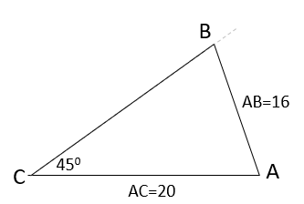
Q1: Determine the value of ∠B.

MARKING:
Beginning 0.0 – 1.0
Progressing 1.5 – 2.0
Competent 2.5
Exemplary 3.0

