L51 – FQ –Cosine Law
Q1: Determine the length of QS. (1 mark) Q2: Determine the measure of ∠R. (1 mark)
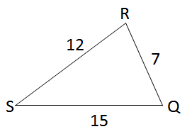
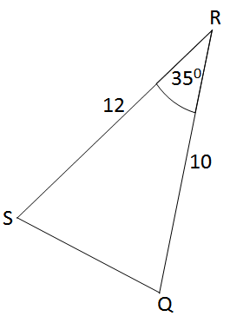

Q3: Solve the triangle. (3 marks)
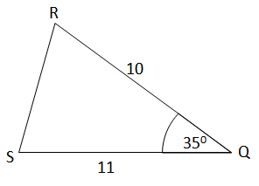

MARKING:
Beginning 0.0 – 2.0
Progressing 2.5 – 3.5
Competent 4.0 – 4.5
Exemplary 5.0

