L52 – FQ – Trigonometry Review
Use the following information to answer Q1:
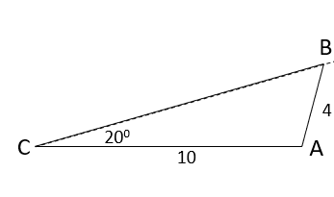
Q1: Determine the value of ∠B. (2 marks)

Q2: Solve the triangle. (3 marks)
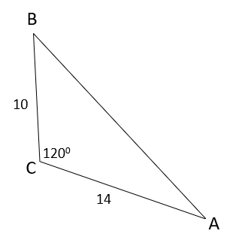

MARKING:
Beginning 0.0 – 2.0
Progressing 2.5 – 3.5
Competent 4.0 – 4.5
Exemplary 5.0

