L52 – Word Problems
Key Ideas
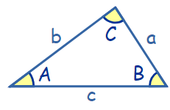
Sine Law:
$\frac{SinA}{a}=\frac{Sin B}{b}=\frac{Sin C}{c}$ or $\frac{a}{Sin A}=\frac{b}{Sin B}=\frac{c}{Sin C}$

Cosine Law:
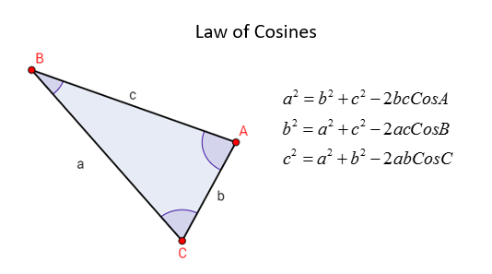
Part 1 – Angle of Inclination, Angle of Declination
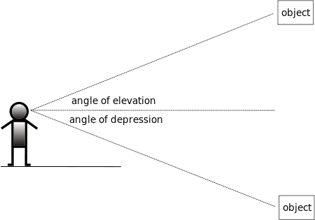

Part 2 – Angle of Inclination, Angle of Declination
Use the following information to answer Q1:
An explorer is trying to determine how far apart two parallel banks of a river are. He walks to a rock and turns 60⁰ from the shore to spot a tree. He then walks 200ft to a bone pile and turns 55⁰ from the shore to spot the same tree.
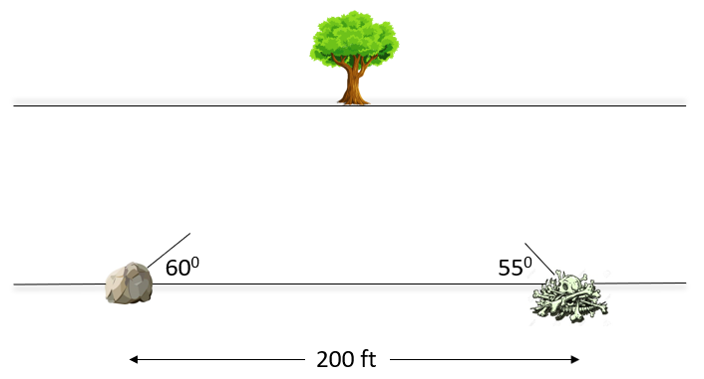
Q1: How far across is the river?

