First Name:______________________________ Last Name:______________________________

L53 – SQ – Trigonometry /12 marks

Comp. | Topic | Multiple Choice |  | Numerical Response |  | Long Answer |  | Total  Marks
Comp. | Topic | Questions | Marks | Questions | Marks | Questions | Marks | Total  Marks
Trigonometry  12 marks | Sine Law | Q1 | 1 | Q2 | 1 |  |  | 2
Trigonometry  12 marks | Sine Law Word Problems | Q3 | 1 |  |  | Q4 | 2 | 3
Trigonometry  12 marks | Cosine Law | Q5 | 1 | Q6 | 1 |  |  | 2
Trigonometry  12 marks | Cosine Law Word Problems | Q7 | 1 | Q8 | 1 |  |  | 2
Trigonometry  12 marks | Solve the Triangle |  |  |  |  | Q9 | 3 | 3

Part 1 – Trigonometry (Trigonometry) ___ / 12 marks ___ / 100%

$$c^{2}=a^{2}+b^{2}-2abCosC$$
$$\frac{SinA}{a}=\frac{SinB}{b}=\frac{SinC}{c}$$
$Sinθ=\frac{o}{h} Cosθ=\frac{a}{h} Tanθ=\frac{o}{a}$
PART 1 – TRIGONOMETRY
Use the following information to answer Q1:
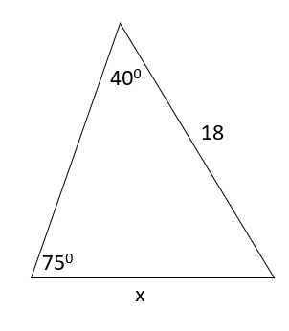
Q1: Determine the value x
- 4.82
- 12.0
- 15.1
- 27.0

Use the following information to answer Q2:
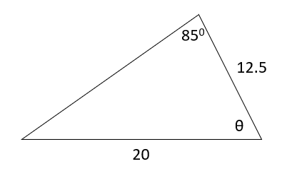
Q2: Determine the value of the angle, θ, to the nearest tenth of a degree.
(Record your three-digit answer in the Numerical Response boxes below)

Use the following information to answer Q3-Q4:
Aerial firefighting makes use of a “water bomber”, or fixed-wing aircraft fitted with tanks that can be filled with water. Two water bombers leave the Ranger’s Tower, and fly in different directions.
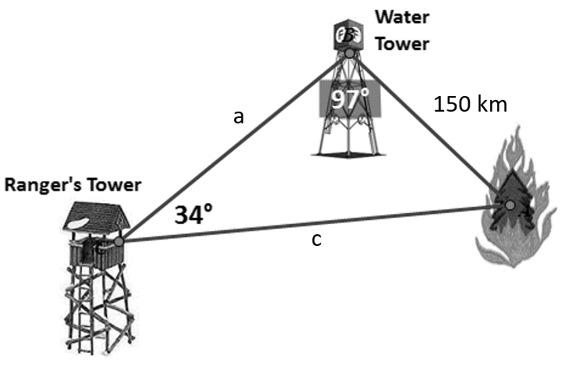
Q3: The first plane is already loaded with water, and flies directly from the Ranger’s Tower to the fire. How far does it travel?
- 85.0 km
- 154 km
- 222 km
- 266 km

Q4: The second plane is empty, and needs to fly first to the Water Tower, then to the fire. Determine the total distance that this plane flies before reaching the fire. (2 marks)

Use the following information to answer Q5:
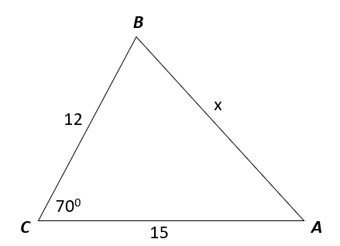
Q5: Determine the value of the side, x
- 13.2
- 14.8
- 15.7
- 16.5

Use the following information to answer Q6:
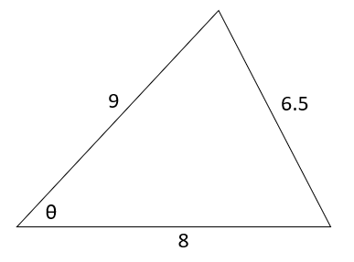
Q6: What is the measure of angle θ, to the nearest tenth of a degree?
(Record your three-digit answer in the Numerical Response boxes below)

Use the following information to answer Q7-Q8:
Robby (on the right) is holding a kite and has let out 110 feet of line. Standing 200ft away, Luke (on the left) is looking up at the kite.
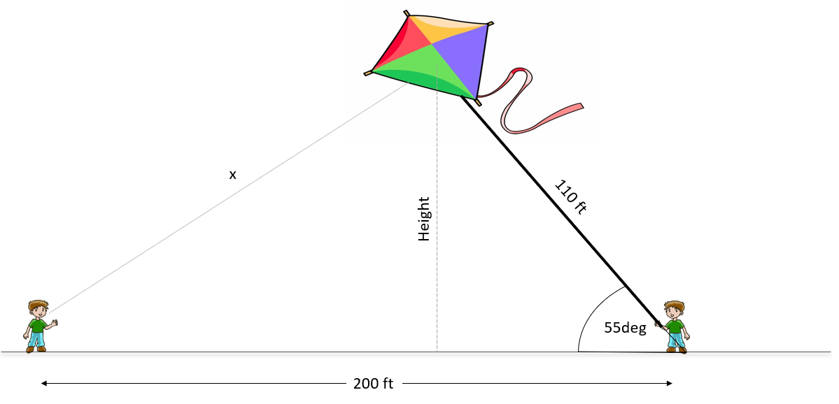

Q7: What is the distance between Luke and the kite, x?
- 68.2 ft
- 98.6 ft
- 164 ft
- 178 ft

Q8: What is the height of the kite above the ground?
(Record your three-digit answer in the Numerical Response boxes below)

Q9: Solve the Triangle (3 marks)
