L56 – Rates
Part 1 – Unit Rates
Unit Price: A unit price is the price for one item or measurement, such as a pound, a kilogram, or a pint, which can be used to compare the same type of goods sold in varying weights and amounts.
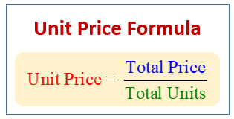
Q1: Bob can pick up 8 cans of beans for $2. What is Unit Price for a single can of beans?

Q2: Often stores will display the Unit Price in the top corner of the price tag. Confirm the Unit Price for each item.
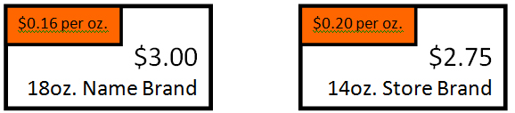

Q3: Determine the Unit Price of the Tetley Tea. Q4: Determine the Unit Price of the toothbrush.
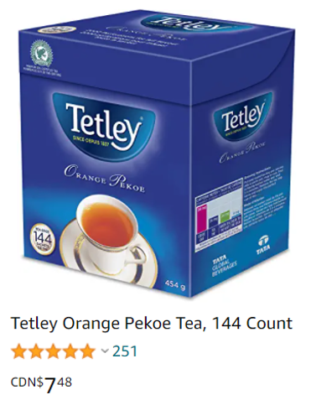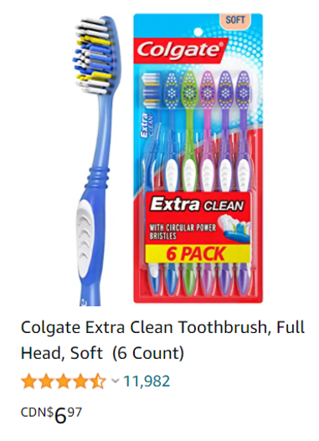

Part 2 – Comparing Unit Rates
Q5: Which can of Folger’s Classic Roast coffee is a better deal? Calculate the Unit Price for each item to justify your answer.
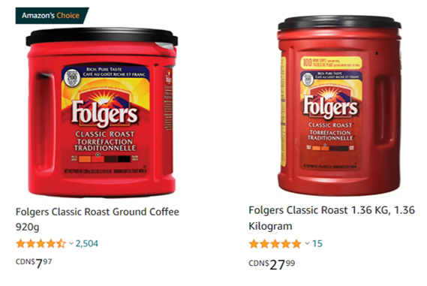

Q6: Which bag of Puma socks is a better deal? Calculate the Unit Price for each item to justify your answer.
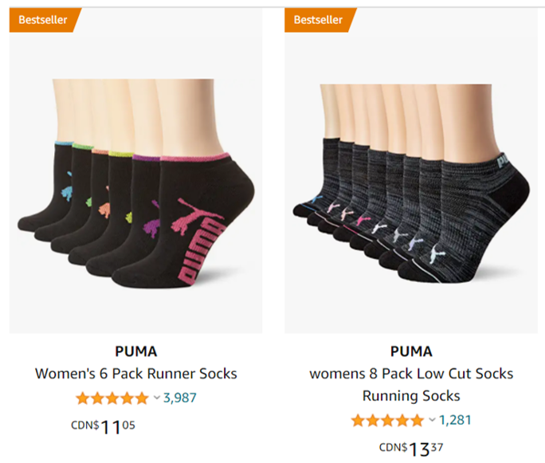

Part 3 – Rates of Change
Use the following information to answer Q7– Q9:
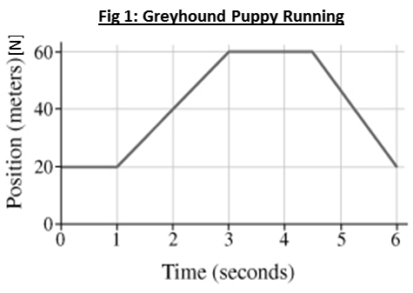

Text

Q7: How fast is the puppy moving between 1 and 3 seconds?

Q8: What is the speed of the puppy at t = 2.0 seconds?
(Record your three digit answer in the Numerical Response boxes below)

Q9: How fast is the puppy moving between 3 and 5 seconds?

Part 4 – Unit Conversions using Proportions
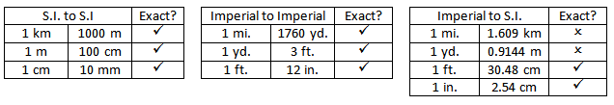
Q10: Convert 2.4km to meters. Q11: Convert 346cm to meters.

Q12: Convert 2000 yards to miles. Q13: Convert 7.8 yards to feet.

Q14: Convert 2.5 miles to kilometers. Q15: Convert 1000 cm to inches.

Part 5 – Unit Conversions using Unit Analysis
Q16: Convert 2.4km to meters. Q17: Convert 346cm to meters.

Q18: Convert 2000 yards to miles. Q19: Convert 7.8 yards to feet.

Q20: Convert 2.5 miles to kilometers. Q21: Convert 1000 cm to inches.

Part 6 – Velocity Conversions (Unit Analysis)
Q22: Convert 100 km/h to m/s.

Q23: Convert 50 cm/s to km/h.

