L57 – Worksheet
Part 1 – Unit Rates
Q1: Josh buys 15lbs of coffee for $210.15. How much does each pound cost? (1 mark)

Q2: Amazon is selling seven Harry Potter books for $212.16. What is the price per book (Unit Price)?
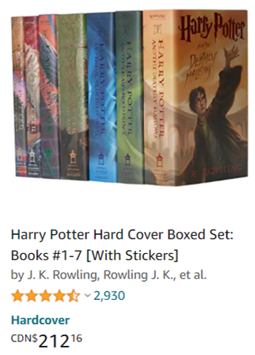

Q3: Amazon is also setting 16 guitar picks for $12.99. What is the Unit Price?
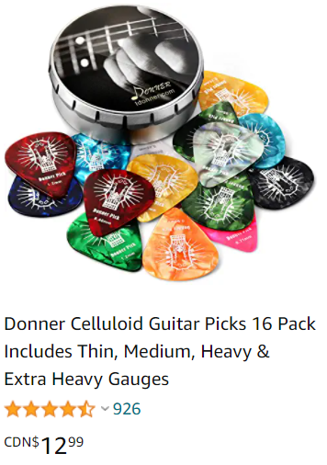
Part 2 – Comparing Unit Rates
Q4: Tim loves apple juice. He can either purchase 3.5L for $2.50 or he can purchase half a dozen 750mL (0.750L) bottles for $3.00. Which is the better deal? Use unit pricing to determine.

Q5: How does the Unit Price of the Cake & Pastry flour compare to the All Purpose flour?
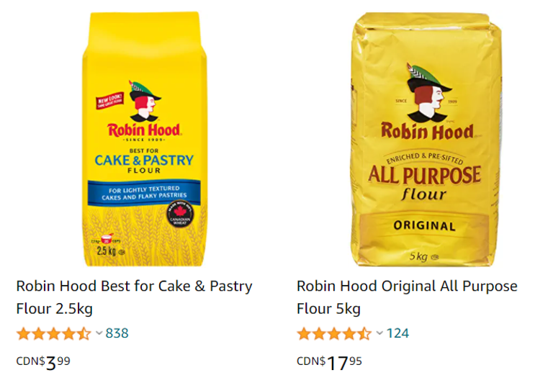
Part 3 – Rates of Change
Use the following information to answer Q6-Q8:
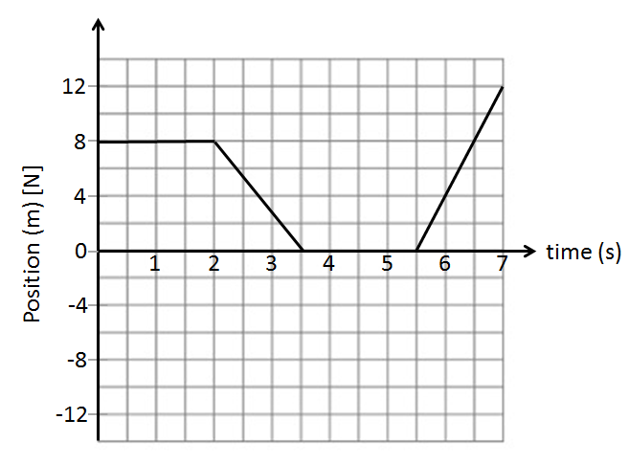

Q6: What is the speed of the object between 0 and 2 seconds?

Q7: What is the speed of the object between 2 and 3.5 seconds?

Q8: What is the speed of the object between 5.5 and 7 seconds?

Use the following information to answer Q9-Q11:
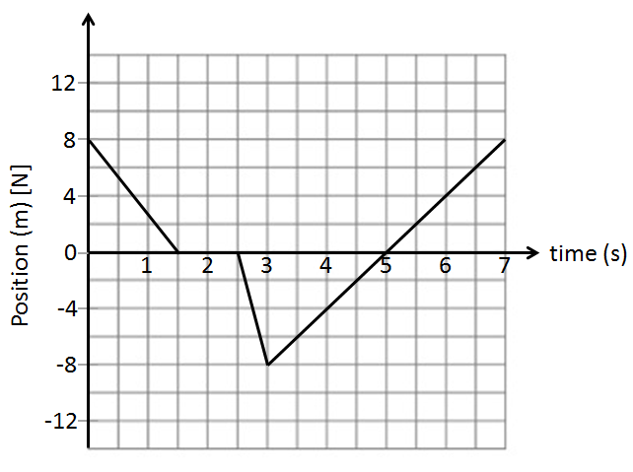

Q9: What is the speed of the object between 0 and 1.5 seconds?

Q10: What is the speed of the object between 3 and 5 seconds?

Q11: What is the speed of the object between 5 and 7 seconds?

Part 4 – Unit Conversions using Proportions
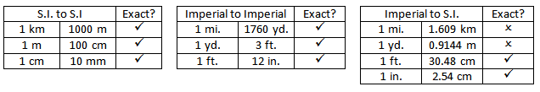
Q12: Convert 585 cm to meters. Q13: Convert 3000 yards to miles.

Q14: Convert 200 yards to meters. Q15: Convert 3.2 miles to yards.

Q16: Convert 2 km to yards.

Q17: Convert 20,000 inches to km.

Part 5 – Unit Conversions using Unit Analysis
Q18: Convert 3.5 km to meters. Q19: Convert 200 feet to yards.

Q20: Convert 5 miles to km. Q21: Convert 300 inches to feet.

Q22: Convert 500 inches to yards.

Q23: Convert 2500 yards to kilometers.

Part 6 – Velocity Conversions (Unit Analysis)
Q24: Highway speed in Canada is typically 100kph. How fast is this in meters per second?

Q25: A cheetah can run up to speeds of 130kph. How fast is that in m/s?

