L58 – Scale Factors
Part 1 – Scale Factor Equation
Scale Factor: A scale factor describes the ratio of the Image dimensions to the object dimensions.
$$SF= \frac{Image}{Object}$$
If the image is enlarged, the image is bigger than the object, and SF > 1.
If the object is reduced, the images is smaller than the object, and SF < 1.
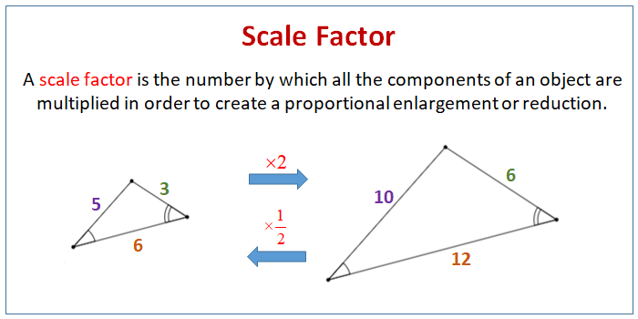

Part 2 – Scale Factor
Use the following information to answer Q1-Q3:
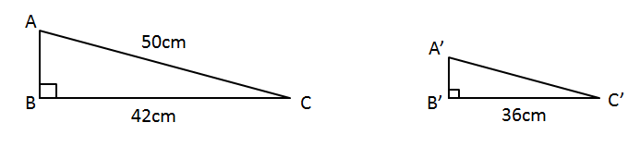
Q1: The original object ABC is reduced to become object A’B’C’. Determine the Scale Factor.

Q2: Determine the length of the side A’C’ using Scale Factor.

Q3: Determine the length of the side A’C’ using Proportions.

Use the following information to answer Q4-Q6:
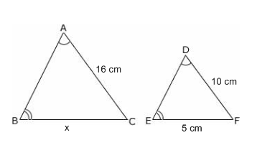
Q4: The original object ABC is reduced to become object DEF. Determine the Scale Factor.

Q5: Determine the length of the side BC using Scale Factor.

Q6: Determine the length of the side BC using Proportions.

Use the following information to answer Q7-Q8:
A Jack Russell Terrier is 36cm tall, and a scaled-down stuffed plushie toy is 20cm tall.
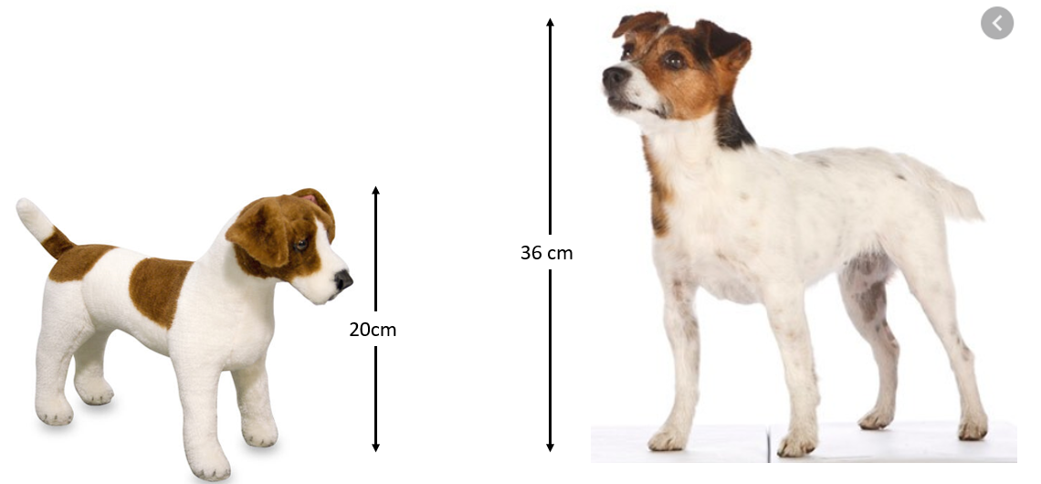
Q7: What is the scale factor used to make the plushie toy, as a decimal?
(Record your 3-digit answer in the Numeric Response boxes below)

Q8: If the length of the real Jack Russell Terrier is 38cm, what is length of the plushie toy?
- 18.9 cm
- 21.1 cm
- 42.6 cm
- 64.8 cm

Q9: A corporation decides that their service robot, which is 6ft tall, could be weaponized for military application. Determine the scale factor of the military robot, as well as the width of its head.
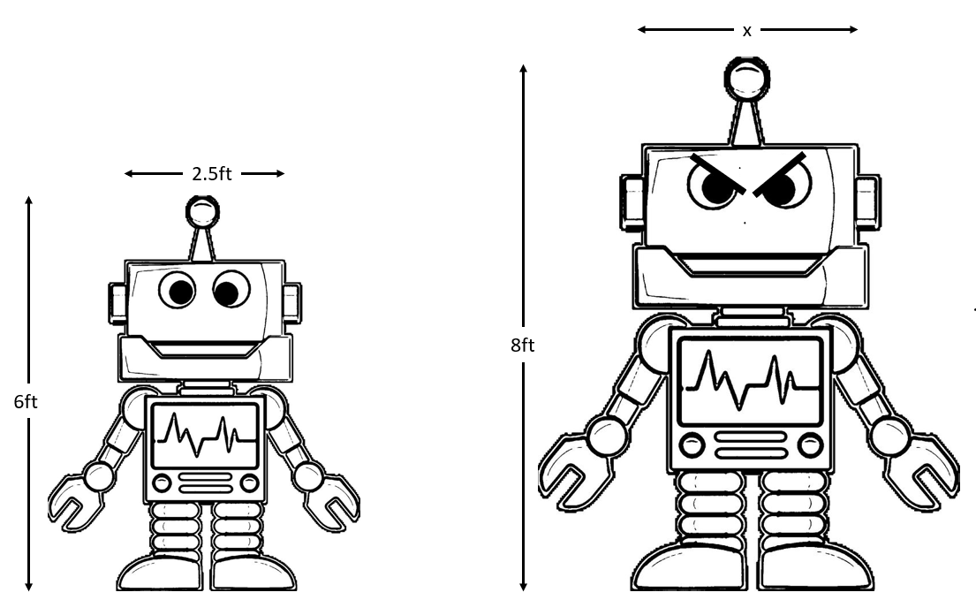

Q10: A children’s toy soldier is 1/8th scale. If a real solder is 175cm tall, how tall is the toy?

Use the following information to answer Q11:
The dinosaur Rugops Primus is shown below, and measures 4.4 meters long.
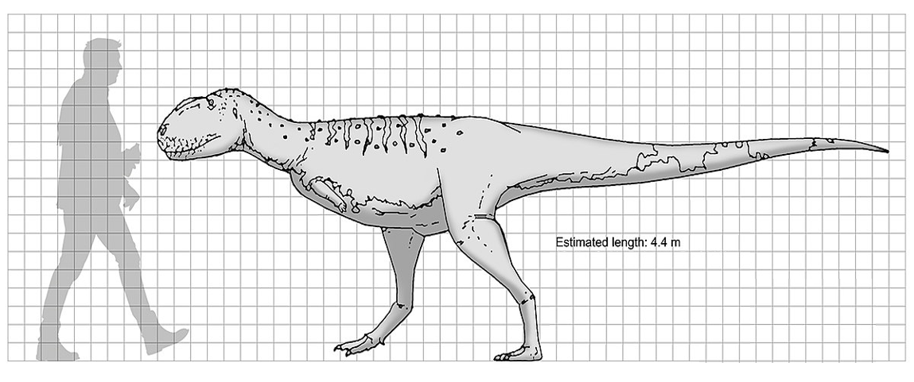
Q11: How tall is Rugops, to the nearest tenth of a meter (one decimal point)? ____________

Part 3 – Scale Factor for Model Toys
Scale Factor can be represented as either $SF=\frac{Image}{Object}$ or as $Image:Object$
For example, a scale model that is 1:18 is equivalent to $SF=\frac{1}{18}$ , and is reduced.
Use the following information to answer Q12-Q13:
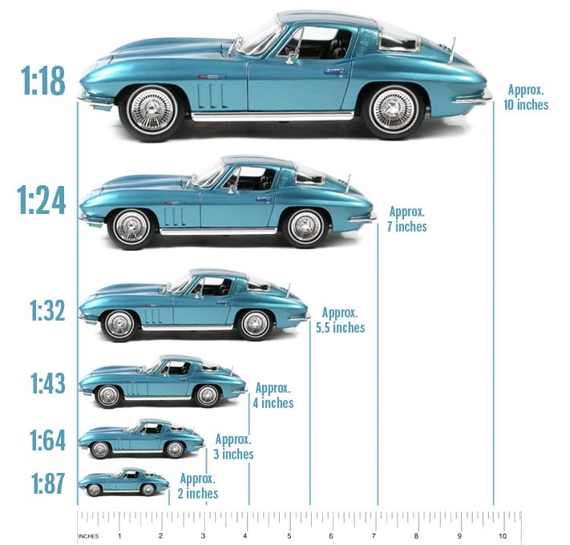

Q12: Using the 1:18 model car, determine the length of the real object.

Q13: Using the 1:64 model car, determine the length of the real object.

Part 4 – Is it Similar?
Q14: You decide that the picture below would make a great Christmas present for your parents. The picture originally measures 10 inches by 14 inches. If you put a 2 inch frame around the entire picture, are the dimensions of the framed picture similar to the original picture? Show your calculations.
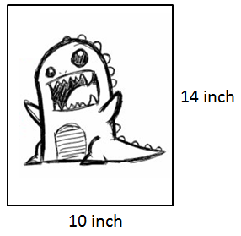

Q15: Determine if the two polygons are similar. Show work to justify your answer.
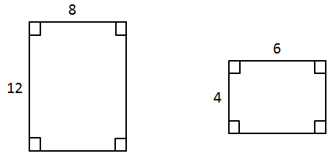

Part 5 – Extra Time?
Colorado PhET – Scale Factor: https://phet.colorado.edu/en/simulation/unit-rates
Colorado PhET – Proportions: https://phet.colorado.edu/en/simulation/proportion-playground

