L59 – Scale Factors of Areas and Volumes
Part 1 – Doubling a Cube
Shape #1:
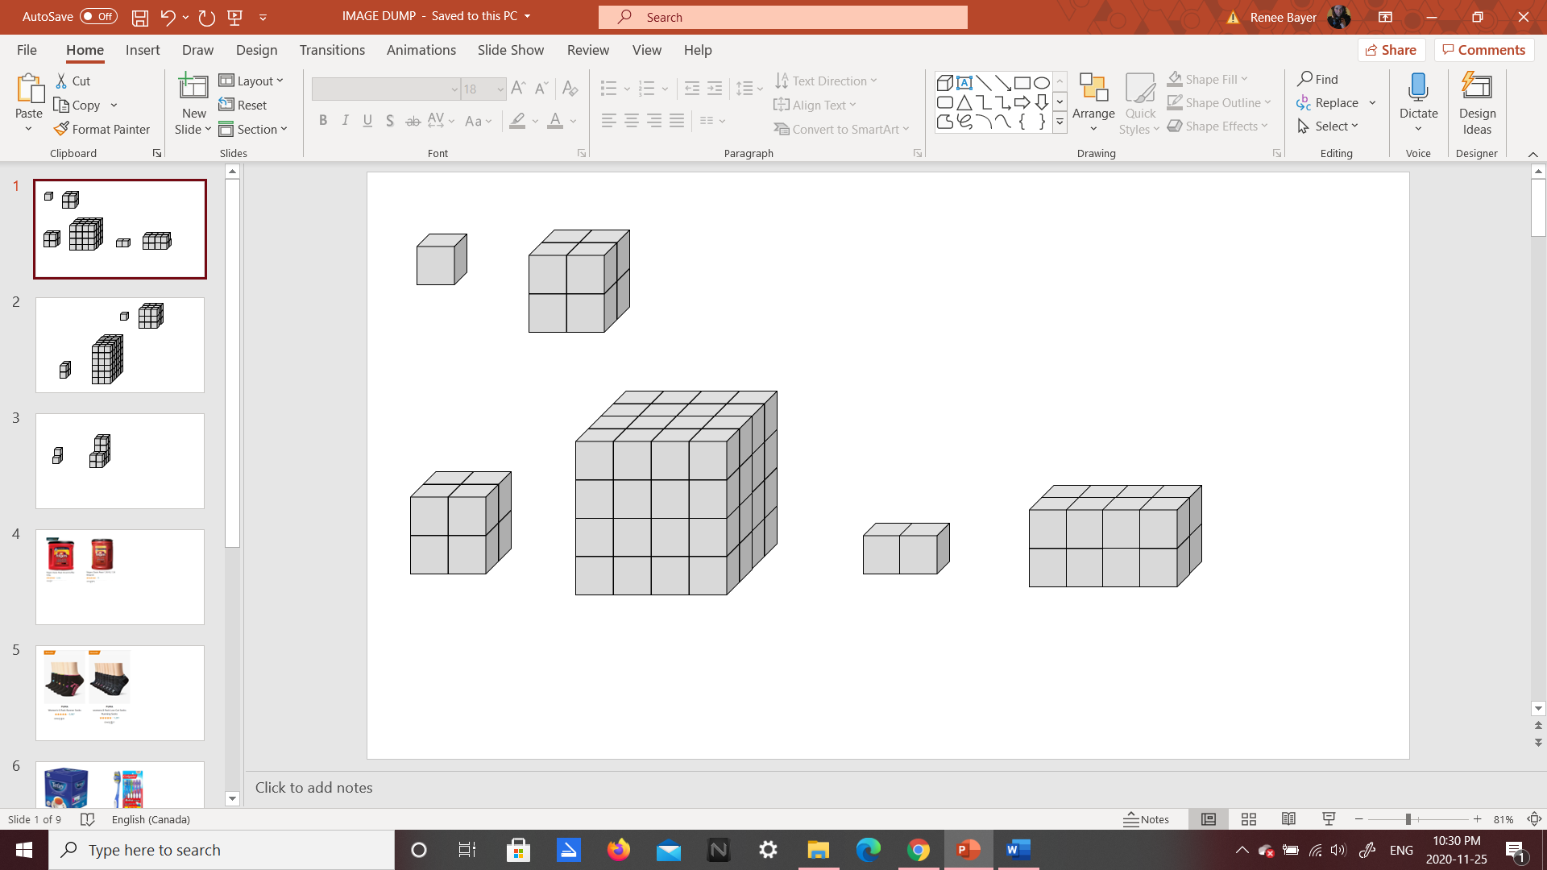
 | Original Shape | …Multiply by… | Larger Shape
Area of Front
Total Surface Area
Total Volume

Shape #2:
 | Original Shape | …Multiply by… | Larger Shape
Area of Front
Total Surface Area
Total Volume
Part 2 – Doubling Other Shapes
Shape #3:
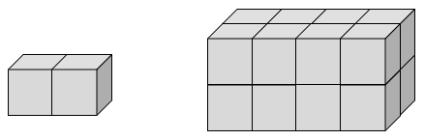
 | Original Shape | …Multiply by… | Larger Shape
Area of Front
Total Surface Area
Total Volume

Shape #4:
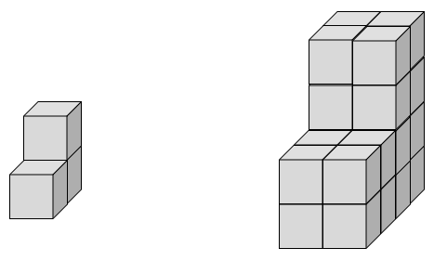
 | Original Shape | …Multiply by… | Larger Shape
Area of Front
Total Surface Area
Total Volume

Part 3 – Tripling a Cube
Shape #5:
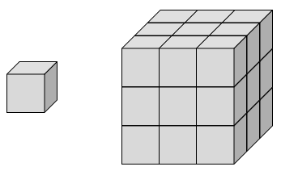
 | Original Shape | …Multiply by… | Larger Shape
Area of Front
Total Surface Area
Total Volume

Part 4 – Tripling Other Shapes
Shape #6:
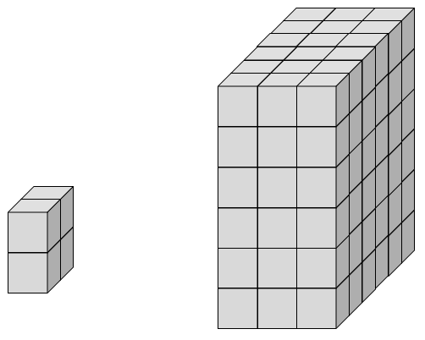
 | Original Shape | …Multiply by… | Larger Shape
Area of Front
Total Surface Area
Total Volume
Part 5 – Scale Factors of Areas and Volumes
For a given Scale Factor…
- Each length of each side increases by SF
- The area of each face increases by SF²
- The total surface area increases by SF²
- The volume increases by SF³
Q1: An object has a total surface area of 100cm². If the size of the object is increased by a Scale Factor of 5, what is the new surface area?

Q2: An object has a volume of 40m³. If each side is reduced by a factor of 0.8, what is the new volume?

Part 6 – Textbook Questions
Pg 479 #3, 4ab, 6abc

