L60 – Worksheet
Part 1 – Areas (Easy)
Q1: By what factor does the length of one side increase? By what factor does the area increase?
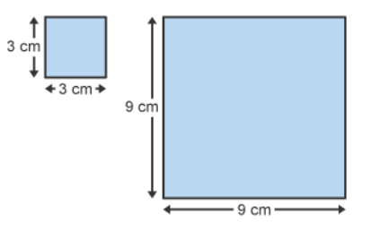

Q2: These two clocks are similar. The area of the small clock face is approximately 50.3 cm². Calculate the area of the face of the larger clock.
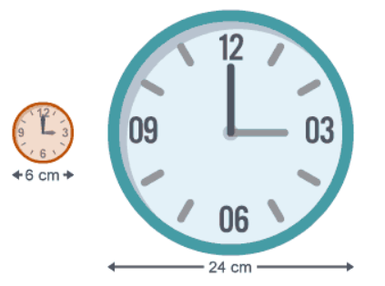

Q3: The figures below are similar. Calculate the missing area.
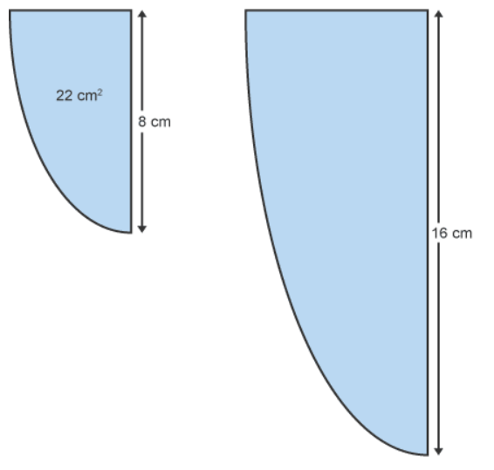
Part 2 – Areas (Hard)
Q4: These two figures are similar. Determine the missing side length, x.
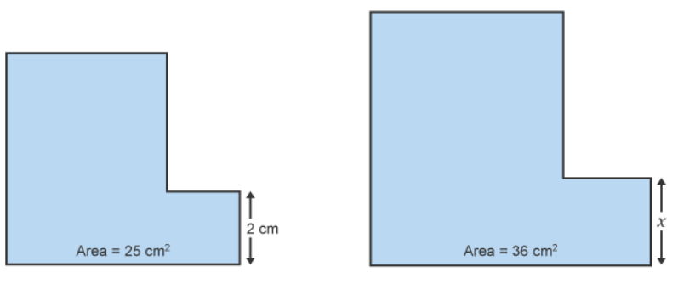

Part 3 – Volume (Easy)
Q5: By what factor does the length of one side increase? By what factor does the volume increase?
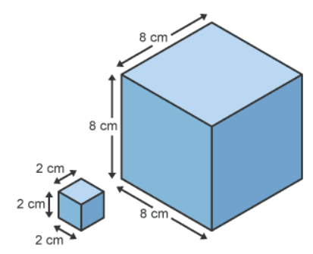

Part 4 – Volume (Hard)
Q6: These two tins of soup are similar. Calculate the diameter of the larger tin of soup.
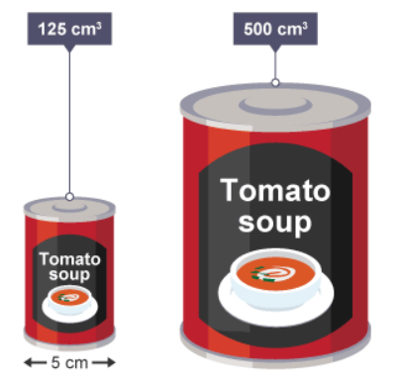

Q7: The vases below are similar. Calculate the missing volume.
