L63 – Assessment – Proportions /15 marks
Part 1 – Unit Rates
Use the following information to answer Q1-Q2:
Prices of Sugar on Amazon.ca
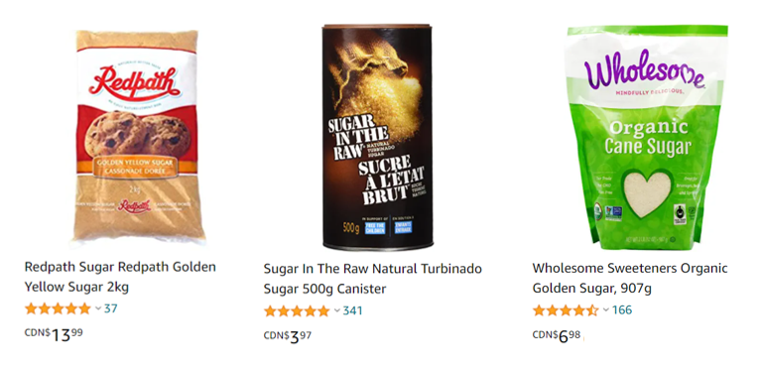
Q1: What is the unit price of the Redpath Golden Yellow Sugar?
(Record your three-digit answer in the Numerical Response boxes below)

Q2: Which has the better unit price, the Sugar in the Raw or the Wholesome Sweeteners? Justify your answer by showing your work. (2 marks)
Part 2 – Rates of Change
Use the following information to answer Q3– Q4:
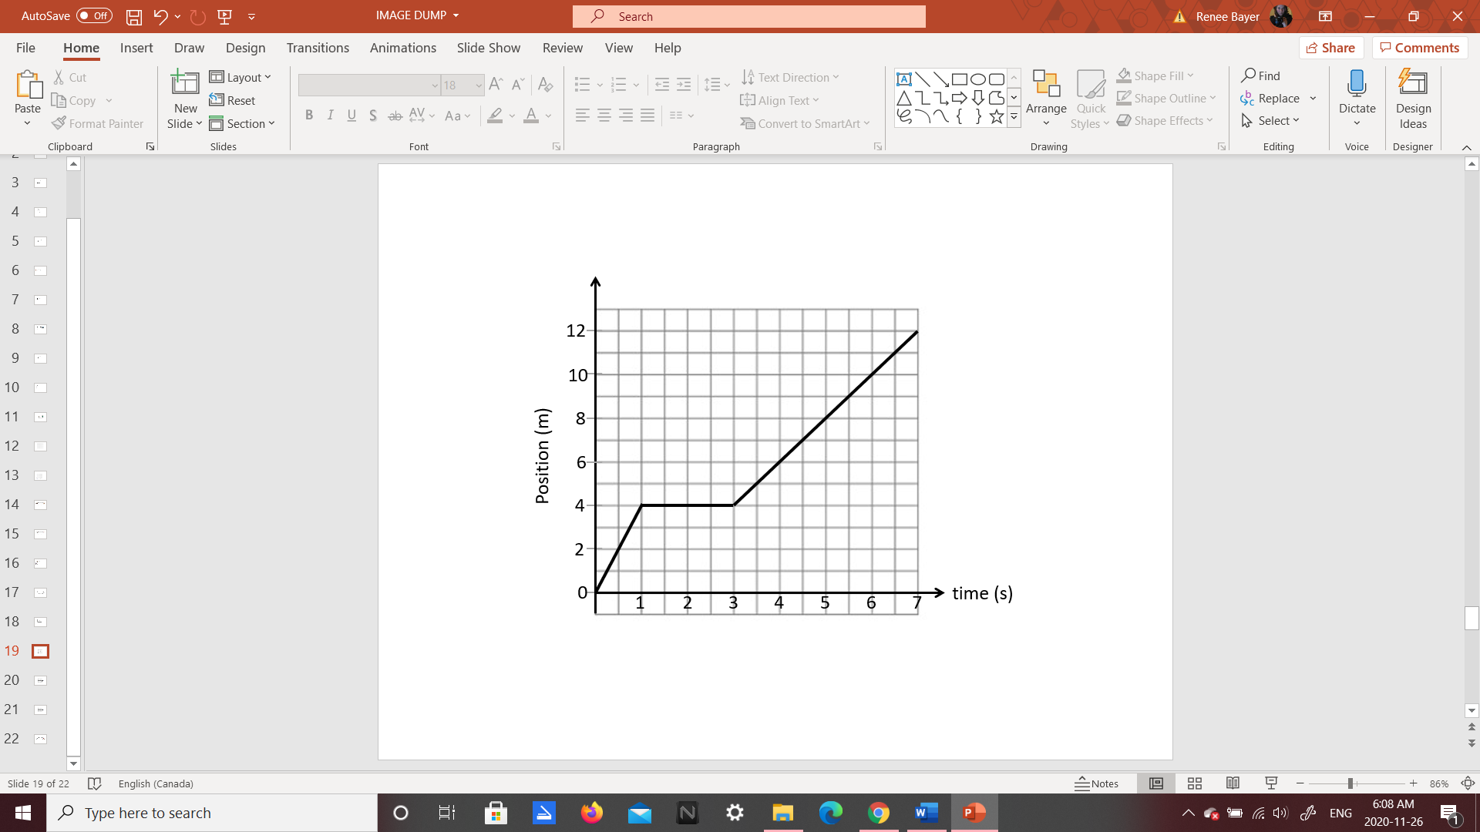

Text

Q3: What is the speed of the object between 3-5 seconds?
- 1.00 m/s
- 1.71 m/s
- 2.00 m/s
- 3.00 m/s

Q4: When is the object moving the fastest? Justify your work by showing calculations. (2 marks)

Part 3 – Unit Conversions using Proportions and Unit Analysis
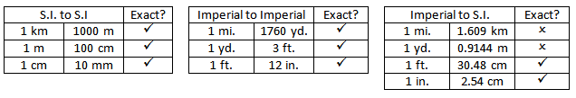
Q5: Using the method of your choice, convert 15 yards to meters. Your answer is _____ meters.
(Record your three-digit answer in the Numerical Response boxes below)

Q6: Convert 18km to yards, using either Proportional Reasoning or Unit Analysis. Show all of your work. (2 marks)

Part 4 – Scale Factors (Length)
Use the following information to answer Q7-8:
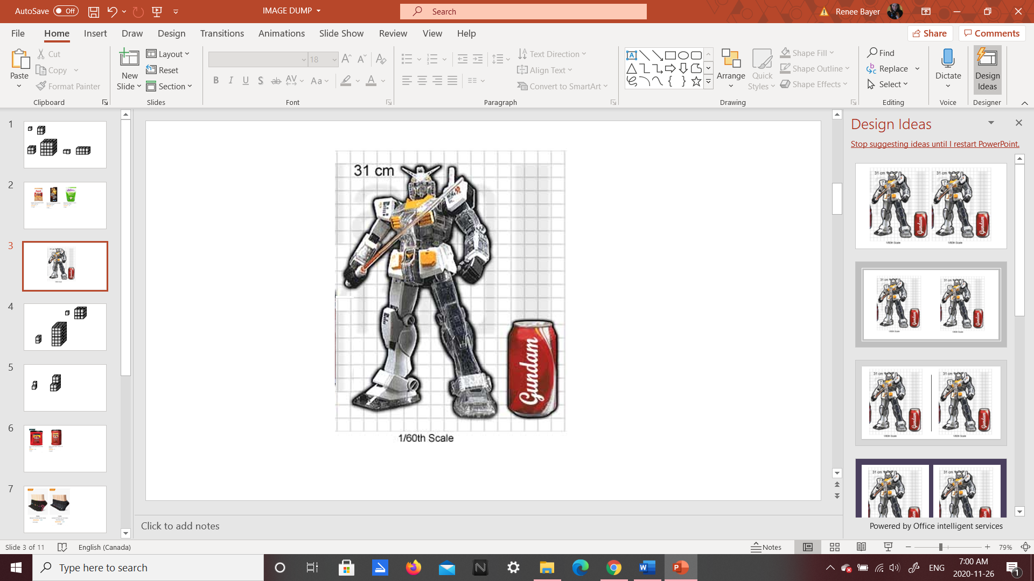

Q7: The scale factor, written as a decimal, is
- 0.017
- 0.527
- 1.935
- 60.00

Q8: Determine the height of the “real” giant Gundam robot, measured in meters. Show your work.
(2 marks)

Part 5 – Scale Factors (Area and Volume)
Use the following information to answer Q9-10:
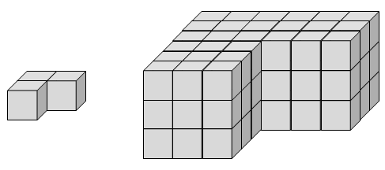

Q9: The diagram on the right has been enlarged using a scale factor of ______.
(Record your three-digit answer in the Numerical Response boxes below)

Q10: If the original shape has a volume of 30cm³, determine the volume of the enlarged shape. Show all of your work. (2 marks)

