First Name:____________________________ Last Name:______________________________

L66-68 – Properties of Angles and Triangles
Competency #6: Use tools and estimation to determine measurements
- 6-1. Derive proofs that involve the properties of angles and triangles.
- 6-2. Solve problems that involve properties of angles and triangles.

Each section, by chapter, will include the following:
- Study Guide
  - Requirements
  - Marking rubric (0-3 marks per study guide item)
  - Space for your study guide
- Summative Questions
  - Includes number of marks per question
Study Guides Summative Questions
▪ 2.1 Study Guide ____ / 6 ▪ 2.1 Questions ____ / 4
▪ 2.2 Study Guide ____ / 3 ▪ 2.2 Questions ____ / 6
▪ 2.3 Study Guide ____ / 6 ▪ 2.3 Questions ____ / 5
▪ 2.4 Study Guide ____ / 6 ▪ 2.4 Questions ____ / 4
▪ 2.5 & 2.6 Study Guide ____ / 3 ▪ 2.5 Questions ____ / 4 ▪ 2.6 Questions ____ / 4
If you have any questions, please see me for additional details. I can also be reached via email at mbayer@clearview.ab.ca if it is the weekend or break.

Chapter 2.1: Exploring Parallel Lines: Study Guide /6
Study Guide Requirements:
- Include definitions explaining and diagrams demonstrating the following:
  - Interior Angles
  - Exterior Angles
  - Corresponding Angles
  - Transversal
- Explain how to use corresponding angles to determine if lines are parallel.
- Explain how to use parallel lines to determine the measure of corresponding angles.
Study Guide Marking Rubric:
 | 3 | 2 | 1 | 0
Terminology:  ▪ 4 Definitions  ▪ 4 Diagrams | Student has met the requirements for all 8 items. | Student has met the requirements for 5-7 of the items. | Student has met the requirements for only 1-4 items. | Not included.
How To Use:  ▪ Angles → Parallel  ▪ Parallel →Angles | Student can clearly articulate how to relate one item to the other. | Student has trouble articulating the relationship between the items. | Student has an incorrect or overly simplified idea of the relationship. | Not included.

Space for your Study Guide:

Chapter 2.1: Exploring Parallel Lines: Summative Questions /4
Q1: In each diagram, is AB parallel to CD? Explain how you know. (4 marks)
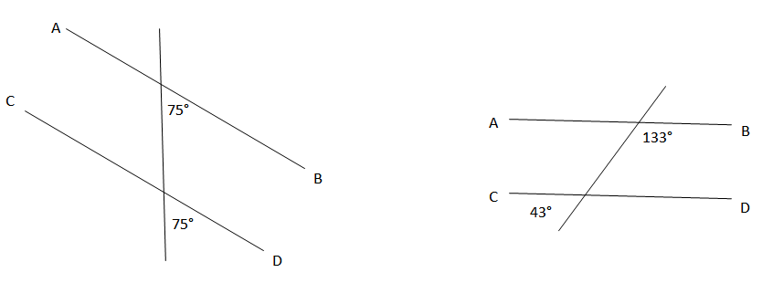

Chapter 2.2: Angles Formed by Parallel Lines: Study Guide /3
Study Guide Requirements:
- Include definitions explaining and diagrams demonstrating the following:
  - Alternating Interior Angles
  - Alternating Exterior Angles
  - Vertically Opposite Angles (HINT: Look at Tuyet’s Solution; Pg 75)
  - Supplementary Angles (HINT: Look at Ali’s Solution; Pg 75)
Study Guide Marking Rubric:
 | 3 | 2 | 1 | 0
Terminology:  ▪ 4 Definitions  ▪ 4 Diagrams | Student has met the requirements for all 8 items. | Student has met the requirements for 5-7 of the items. | Student has met the requirements for only 1-4 items. | Not included.

Space for your Study Guide:

Chapter 2.2: Angles Formed by Parallel Lines: Summative Questions /6

Q2: Determine the measure of ∠c and ∠b. For each, explain how you were able to determine this, using your terminology from this chapter. (2 marks for correct angle measures, 2 marks for explanations; 4 marks total)
▪ Corresponding Angles ▪ Alternating Interior Angles ▪ Alternating Exterior Angles
▪ Vertically Opposite Angles ▪ Supplementary Angles
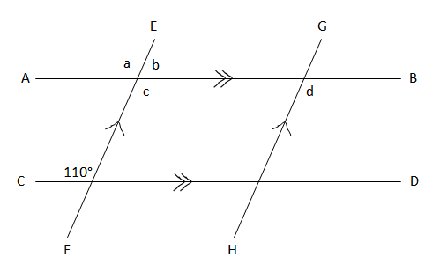

Q3: Using your terminology, what is the relationship of ∠d to ∠c? (1 mark)

Q4: Using your terminology, what is the relationship of ∠d to ∠a? (1 mark)

Chapter 2.3: Angle Properties in Triangles: Study Guide /6
Study Guide Requirements:
- Include definitions explaining and diagrams demonstrating the following:
  - Exterior Angle
  - Non-Adjacent Interior Angles
- Explain the relationship between an Exterior Angle and the Non-Adjacent Interior Angles
Study Guide Marking Rubric:
 | 3 | 2 | 1 | 0
Terminology:  ▪ 2 Definitions  ▪ 2 Diagrams | Student has met the requirements for all 4 items. | Student has met the requirements for 3 of the items. | Student has met the requirements for only 1-2 items. | Not included.
Relationship:  ▪ Exterior Angle and Non-Adjacent Interior Angles | Student can clearly articulate how to relate one item to the other. | Student has trouble articulating the relationship between the items. | Student has an incorrect or overly simplified idea of the relationship. | Not included.

Space for your Study Guide:

Chapter 2.3: Angle Properties in Triangles: Summative Questions /5
Q5: Determine the measure of ∠a. Explain how you reached this conclusion. (2 marks)
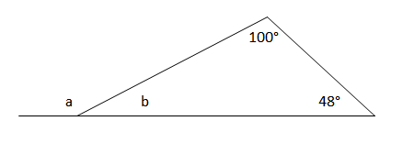

Q6: Determine the measures of ∠a, ∠b, and ∠c. (3 marks)
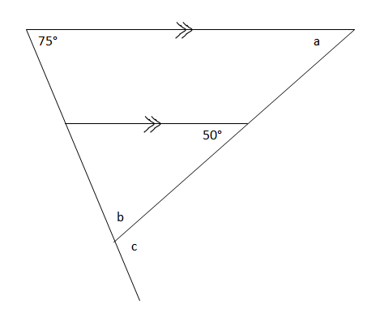

Chapter 2.4: Angle Properties in Polygons: Study Guide /6
Study Guide Requirements:
- Include definitions explaining and diagrams demonstrating the following:
  - Convex Polygon
  - Regular Polygon (HINT: Look at Nazra’s Solution; Pg 97)
- Prove that the sum of the measures of the interior angles of any n-sided convex polygon can be expressed as 180°(n-2).
Study Guide Marking Rubric:
 | 3 | 2 | 1 | 0
Terminology:  ▪ 2 Definitions  ▪ 2 Diagrams | Student has met the requirements for all 4 items. | Student has met the requirements for 3 of the items. | Student has met the requirements for only 1-2 items. | Not included.
Proof:  ▪ Sum of angles of any convex polygon is 180°(n-2) | Student has included a diagram and can clearly articulate, in their own words, how to derive this relationship. | Student has trouble articulating how to derive this relationship. | Student has simply copied the derivation from the textbook, and has not demonstrated understanding. | Not included.

Space for your Study Guide:

Chapter 2.4: Angle Properties in Polygons: Summative Questions /4
Q7: Determine the measures of ∠AFE and ∠AED in the regular polygon below. (2 marks)
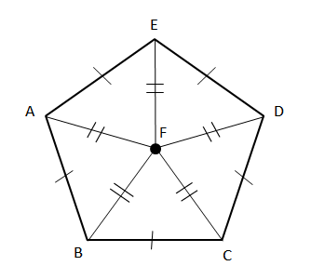

Q8: LMNOP is a regular pentagon. Determine the measure of ∠OLN. (2 marks)
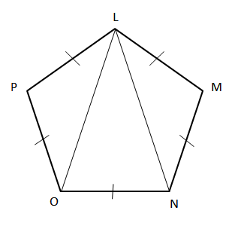
Chapter 2.5&2.6: Congruent Triangles: Study Guide /3
Study Guide Requirements:
- Include definitions explaining or diagrams demonstrating the following:
  - Definition: Congruent Triangles (∆ABC ≅ ∆DEF)
  - Diagram: SSS
  - Diagram: SAS
  - Diagram: ASA
Study Guide Marking Rubric:
 | 3 | 2 | 1 | 0
Terminology:  ▪ 1 Definition  ▪ 3 Diagrams | Student has met the requirements for all 4 items. | Student has met the requirements for 3 of the items. | Student has met the requirements for only 1-2 items. | Not included.

Space for your Study Guide:

Chapter 2.5: Exploring Congruent Triangles: Summative Questions /4
Q9: State if the two triangles are congruent. If they are, state how you know. (4 marks)
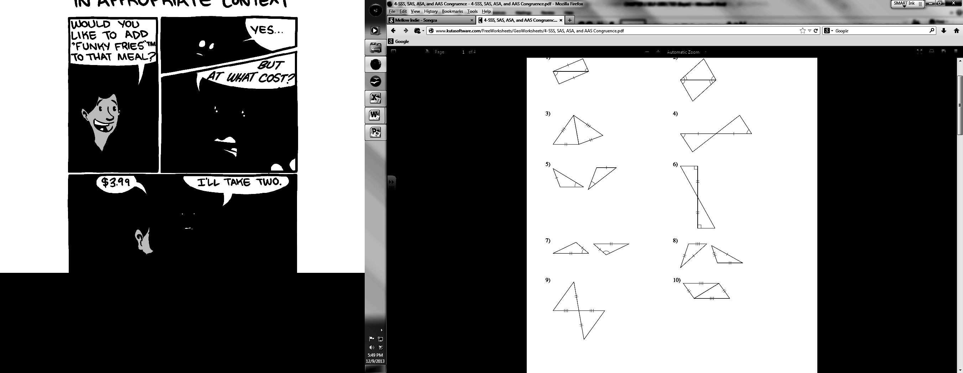

Chapter 2.6: Proving Congruent Triangles: Summative Questions /4
Q10: Given that WY bisects (cuts in half) ∠XWZ and ∠XYZ, prove that XY = ZY. (2 marks)
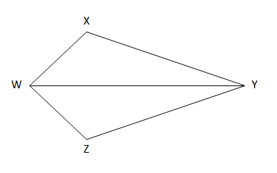

Q11: Prove that ∆ABC ≅ ∆AED. (2 marks)
