First Name:______________________________ Last Name:______________________________
L99 – Unit Test – Radicals and Quadratic Functions – Part 1 - RETEST
Comp. | Topic | Multiple Choice |  | Numerical Response |  | Long Answer |  | Total  Marks
Comp. | Topic | Questions | Marks | Questions | Marks | Questions | Marks | Total  Marks
Radicals  8 marks | Adding and Subtracting Radicals |  |  | Q1 | 1 |  |  | 1
Radicals  8 marks | Multiplying Radicals | Q2 | 1 |  |  |  |  | 1
Radicals  8 marks | Dividing Radicals | Q3 | 1 |  |  |  |  | 1
Radicals  8 marks | Rationalizing the Denominator |  |  | Q4 | 1 |  |  | 1
Radicals  8 marks | Radical Equations | Q5 | 1 |  |  | Q6 | 3 | 4
Graphing  Functions  4 marks | Identifying Vertex Form Equation from Graph | Q8 | 1 |  |  |  |  | 1
Graphing  Functions  4 marks | Identifying Points from a Graph |  |  | Q9 | 1 |  |  | 1
Graphing  Functions  4 marks | Graphing Standard Form |  |  |  |  | Q10 | 2 | 2
Graphing  Equations  4 marks | Solving a Quadratic Eqn. by Graphing | Q11 | 1 |  |  |  |  | 1
Graphing  Equations  4 marks | Word  Problems |  |  |  |  | Q12 | 3 | 3

Part 1 – Radicals (Algebra) ___ / 8 marks ___ / 100%
Part 2 –Quadratic Functions (Graphing) ___ / 4 marks ___ / 100%
Part 3 –Quadratic Equations (Graphing) ___ / 4 marks ___ / 100%

PART 1 – RADICALS
Q1: The expression $\sqrt{20}+\sqrt{18}-\sqrt{45}+\sqrt{32}$ simplifies to $a\sqrt{b}-c\sqrt{d}$ , where a, b, c, and d are ___, ___, ___, and ___.
(Record your four-digit answer in the Numerical Response boxes below)

Q2: The expression $\left(2\sqrt{3}-4\right)\left(5\sqrt{3}-1\right)$ simplifies to
- $4-4\sqrt{3}$
- $4-12\sqrt{3}$
- $32-20\sqrt{3}$
- $34-22\sqrt{3}$

Use the following information to answer Q3:
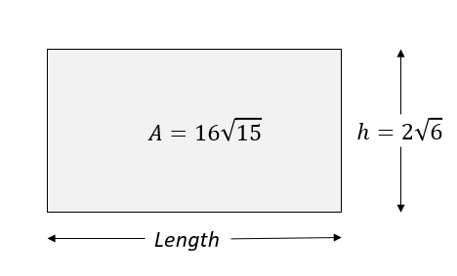
Q3: The height of the rectangle is
- $3\sqrt{17}$
- $4\sqrt{10}$
- $8\sqrt{9}$
- $24\sqrt{10}$

Q4: The expression $\frac{4\sqrt{2}+8}{\sqrt{2}}$ simplifies to $a+b\sqrt{c}$ , where a, b, and c are ___, ___, and ___.
(Record your three-digit answer in the Numerical Response boxes below)

Q5: Determine the solutions to the equation $\sqrt{5+x}=8$
- $x=9$
- $x=11$
- $x=39$
- $x=59$

Q6: Solve the equation $2\sqrt{3x+1}=6$ , and verify the solution(s). (3 marks)

PART 2 –GRAPHING QUADRATIC FUNCTIONS
Use the following information to answer Q8-Q9:
A graph for a particular function is given below:
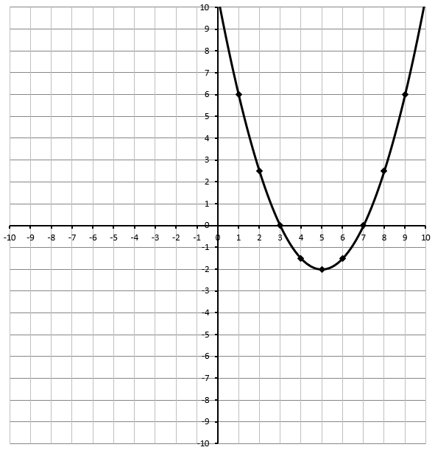

Q8: The equation which best describes the graph is
- $y=\frac{1}{2}{\left(x-5\right)}^{2}-2$
- $y=1{\left(x-5\right)}^{2}-2$
- $y=\frac{1}{2}{\left(x+5\right)}^{2}-2$
- $y=1{\left(x+5\right)}^{2}-2$

Q9: Determine the minimum value of the function, to the nearest tenth. (1 mark)

Q10: Graph the function $f\left(x\right)={-x}^{2}-6x-5$ below, clearly showing: (2 mark long answer)
- Zeroes
- Vertex
- Axis of Symmetry
- Y-Intercept
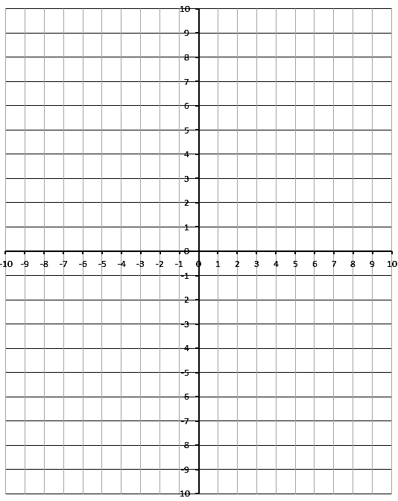

PART 3 –GRAPHING QUADRATIC EQUATIONS
Use the following information to answer Q11:
A student is attempting to solve the quadratic equation $\frac{1}{4}x^{2}-3=x$. The approach the problem by graphing the function $f\left(x\right)=\frac{1}{4}x^{2}-1x-3$ , shown below.
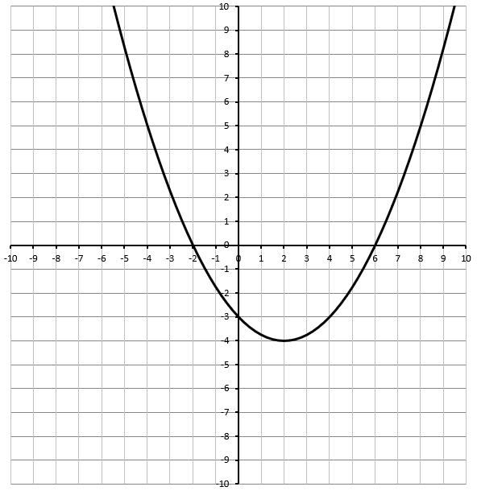
Q11: The solution to the problem is
- $x_{1}=0, x_{2}=4$
- $x_{1}=-2, x_{2}=6$
- $y=-3$
- $(2,-4)$

Use the following information to answer Q12:
A kangaroo jumps off a 3.5 ft ledge, and lands an unknown distance, d_{x} , from her starting point.
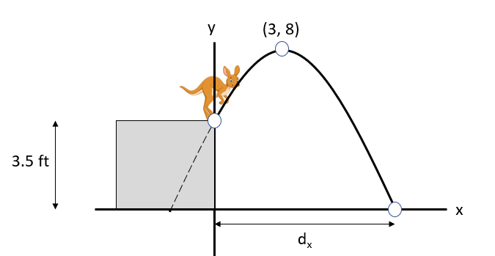
Q12: If the kangaroo reached a maximum height of 8 ft after travelling a horizontal distance of 3 ft, how much horizontal distance, d_{x} , did the kangaroo cover before landing? (3 marks)
