First Name:______________________________ Last Name:______________________________
L99 – Unit Test – Radicals and Quadratic Functions – Part 2 - RETEST
Comp. | Topic | Multiple Choice |  | Numerical Response |  | Long Answer |  | Total  Marks
Comp. | Topic | Questions | Marks | Questions | Marks | Questions | Marks | Total  Marks
Algebra  (Chapter 3)  8 marks | Build Vertex from Two Points |  |  |  |  | Q1 | 3 | 3
Algebra  (Chapter 3)  8 marks | Convert from Vertex to Standard | Q2 | 1 |  |  |  |  | 1
Algebra  (Chapter 3)  8 marks | Convert from Standard to Factored to Vertex | Q3  Q4 | 1  1 |  |  | Q5 | 2 | 4
Algebra  (Chapter 4)  8 marks | Solving a Quadratic Eqn. using Factoring | Q6 | 1 |  |  | Q7 | 2 | 3
Algebra  (Chapter 4)  8 marks | Solving a Quadratic Eqn. by Quadratic Formula | Q8 | 1 |  |  | Q9 | 2 | 3
Algebra  (Chapter 4)  8 marks | Word Problems |  |  |  |  | Q10 | 2 | 2

Part 4 – Chapter 3 Quadratic Functions (Algebra) ___ / 8 marks ___ / 100%
Part 5 – Chapter 4 Quadratic Equations (Algebra) ___ / 8 marks ___ / 100%

PART 4 – CHAPTER 3 ALGEBRA
Use the following information to answer Q1:
A vertex of a parabola is located at (-2,6). The parabola also passes through the point (1,-3).
Q1: Build the equation, in Vertex Form. Show all your work. (3 marks)

Use the following information to answer Q2:
A quadratic function, in Vertex Form, is modelled as $y=\frac{1}{2}{(x-4)}^{2}-6$
Q2: The equation, in Standard Form, is
- $y=\frac{1}{2}x^{2}-4x-2$
- $y=\frac{1}{2}x^{2}-4x+2$
- $y=\frac{1}{2}x^{2}+4x-2$
- $y=\frac{1}{2}x^{2}+4x+2$

Use the following information to answer Q3-Q5:
$$f\left(x\right)=x^{2}+x-12$$
Q3: When converted into Factored Form, the equation is
- $f\left(x\right)=(x-2)(x+6)$
- $f\left(x\right)=(x+2)(x-6)$
- $f\left(x\right)=(x-3)(x+4)$
- $f\left(x\right)=(x+3)(x-4)$
Q4: The Axis of Symmetry is located at
(Mistakes from Q3 carry through to Q4)
- $x=-2$
- $x=-\frac{1}{2}$
- $x=\frac{1}{2}$
- $x=2$
Q5: Express the function in Vertex Form. (2 marks)
(Mistakes from Q4 carry through to Q5)

PART 5 – CHAPTER 4 ALGEBRA
Use the following information to answer Q6 and Q7:
$$x^{2}-24=10x$$
Q6: The equation can be written in factored form prior to solving for x. Which factored form can be used to solve for x?
- $\left(x-12\right)\left(x+2\right)=0$
- $\left(x-6\right)\left(x-4\right)=0$
- $\left(x-2\right)\left(x+12\right)=0$
- $\left(x+4\right)\left(x+6\right)=0$

Q7: Determine the solutions to the equation Show all work. (2 marks)
(Mistakes from Q6 carry through to Q7)

Use the following information to answer Q8-Q9:
When a quadratic equation is not factorable, the equation can always be solved using the Quadratic Equation. The following equation is not factorable:
$$x^{2}+3x-6=0$$
The Quadratic Equation is given by:
$$x=\frac{-b±\sqrt{b^{2}-4ac}}{2a}$$
Q8: Which of the following best shows the setup of this solution?
- $x=\frac{-(-6)±\sqrt{{(-6)}^{2}-4(1)(3)}}{2(1)}$
- $x=\frac{-(-6)±\sqrt{{(-6)}^{2}-4(3)(1)}}{2(3)}$
- $x=\frac{-(3)±\sqrt{{(3)}^{2}-4(1)(-6)}}{2(1)}$
- $x=\frac{-(1)±\sqrt{{(1)}^{2}-4(3)(-6)}}{2(3)}$

Q9: Determine the solutions to this equation. (2 marks)
(Mistakes from Q8 carry through to Q9)

Use the following information to answer Q10:
Two friends are in the middle of a football field playing baseball. The baseball is hit into the air, only to be caught again from the same level it was hit from.
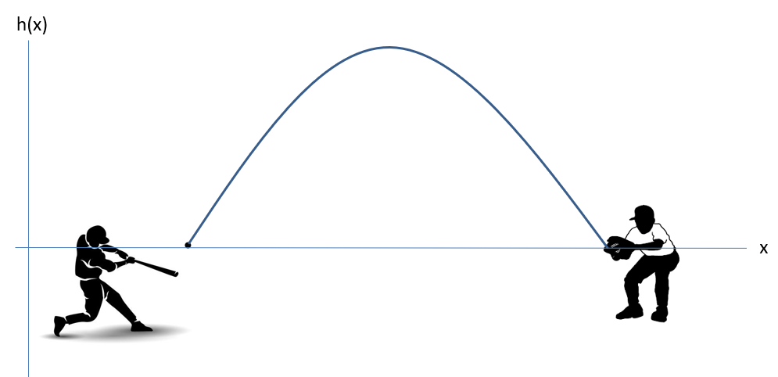
The height of the baseball above the initial hit position, as a function of horizontal distance, is given by the equation
$$h\left(x\right)=-x^{2}+12x-20$$
All units are in meters.
Q10: Algebraically determine the maximum height of the baseball above the position from which it was hit. Show all work. (2 marks)

